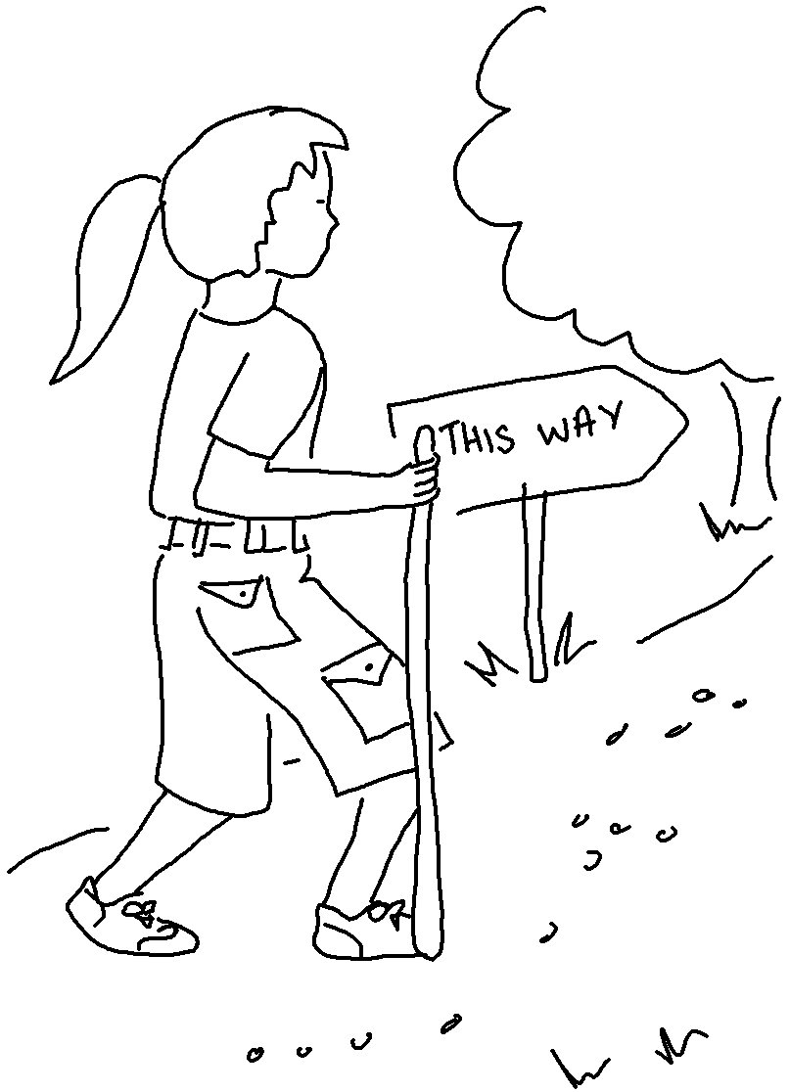
Don't say, "I’m too _ _ _ _ _," for you must go wherever I _ _ _ _ you and say whatever I _ _ _ _ you.
Jeremiah 1:7_{NLT}

